S/O, RAJENDHRAN. A, 4-10-1 MALAIYUR , PAVITHIRAM (PO), PUGALUR (TK),

KARUR-639002.

# CAREER OBJECTIVE

YOGESHWARAN.R

MOBILE NO.:+91 6382388521

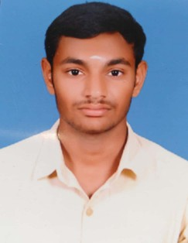

EMAIL: [yogeshwaran2210@gmail.com](mailto:yogeshwaran2210@gmail.com)

To be asocial with the firm, this provides career development opportunities And contributes in its progress through my knowledge and skills

# EDUCATION

|  |  |  |  |  |
| --- | --- | --- | --- | --- |
| COURSE | SCHOOL/COLLEGE | BOARD/ UNIVERSITY | YEAR OF PASS NG | PERCENTAGE |
| BCA | NANDHA ARTS AND SCIENCE COLLEGE,  ERODE | BHARATHIAR UNIVERSITY | 2022 | 69% |
| HSC | STAR MATRIC HR. SEC. SCHOOL,  KARUR | STATE BOARD | 2019 | 74% |
| SSLC | STAR MATRIC HR. SEC. SCHOOL,  KARUR | STATE BOARD | 2017 | 89% |

SKILLS SET

* C
* C++
* HTML
* Microsoft office

# EXTRA CURRICULAR ACTIVITIES

* Online courses
* Basic computer course

# PROJECT

* Online Health Center Automation

# STRENGTH

* Self motivated
* Hardwork
* honesty

# INTERESTS

* Watching movie
* Football

# PERSONAL DETAILS

* + Date of Birth : 22.10.2001
  + Gender : Male
  + Marital Status : Unmarried
  + Nationality and Religion : Indian/ Hindu
  + Languages Known : Tamil and English

# DECLARATION

I hereby declare that the details given above are true to the best of my knowledge and belief.

SIGNATURE

(yogeshwaran.r)